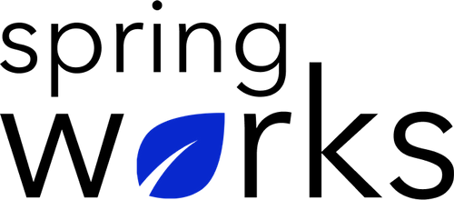
Free Template – Employer Improvement Survey

Use this survey to get a valuable criticism about the organisation.

Employer Improvement survey helps in planning ways to organisational processes on the basis of constructive criticism from the employees. Copy this template to your Google Drive and customize it for your organization.

Communication (to be added as review instructions):

We can only make positive changes when we have the right information. All answers you give will be treated with the utmost sensitivity, and the information will not be used for any other purpose apart from planning and improvement. Please answer this quick survey by <HOUR OF THE DAY> on <DATE>.

Demographic Information:

The following information is requested so that meaningful analysis and comparisons of group results can be made. Please check the circle, corresponding to your answer.

Q: Your Gender:

- Male
- Female

Q: Your Department:

- Marketing
- Operations
- Tech
- Accounting
- HR

Q: Company Service:

- Under 1 Year
- 1-2 Year
- 3-5 Year
- 6-10 Year
- 10-15 Year
Employer Improvement Survey

To answer clearly what you think or feel about each item, please follow these steps:

- Read each item fully before you start to mark your answer.
- Pick the one answer which most nearly says what you think or how you feel.
- While completing the questions, be sure to read the special instructions which are included.

Choose the answer which is most appropriate (Strongly Agree = 5 and Strongly Disagree =1)

Q: How long have you been working under your manager:

- Under 1 Year
- 1-2 Years
- 3-5 Years
- 6-10 Years
- More than 10 Years

Q: My organisation takes charge of my professional development:

- 5
- 4
- 3
- 2
- 1
- N/A

Q: Does the CEO of the organisation clearly communicate organisational goals?

- Yes
- No

Q: In case of any personal problem I find it convenient to approach the management:

- 5
- 4
- 3
- 2
- 1
- N/A

Q: My manager does not believe in favouritism:

- 5
- 4
- 3
- 2
- 1
- N/A

Q: The CEO listens to the concerns of every employee patiently:

- 5
- 4
- 3
- 2
- 1
- N/A

Q: How frequently does your organisation organises award recognition events:

- 5-10 times a month
- Twice a month
- Once a month
- Rarely
- Never

Q: We can talk to our management about any conflicts in the team:

- 5
- 4
- 3
- 2
- 1
- N/A

(If you agree, please list a few examples when your conflicts have been resolved).

Q: All the doubts are answered well by our manager:

- 5
- 4
- 3
- 2
- 1
- N/A

Q: Does your manager explain the reasons behind the decisions made?

- Yes
- No

Q: My CEO thinks for the organisation’s best interest:

- 5
- 4
- 3
- 2
- 1
- N/A

Q: The management maintains high standards for their conduct:

- 5
- 4
- 3
- 2
- 1
- N/A

Q: The work is explained with the clear instructions:

- 5
- 4
- 3
- 2
- 1
- N/A

Q: What is the total satisfaction level with your manager?

- Very satisfied
- Satisfied
- Neutral
- Unsatisfied
- Very Unsatisfied

Q: The three things the manager worked to improve on issues in the last year?

i.
ii.
iii.

Q: List any three development programs conducted for personal growth?

i.
ii.
iii.

Q: What else would you like to tell us about?

Many thanks for taking the time to fill in this survey.

